**Singapore HDB Flat Resale Price Prediction**

1. Total number of parameters in my initial model is **6,629.**

2. Number of layers used in my initial model is **3.** (2 hidden layers and 1 output layer)

3. Model Improvement Analysis:

1. Training Time Analysis

Deeper models require longer training times as they contain more parameters. The 3-layer model trains fastest, while the 7-layer model takes the most time due to its greater complexity.

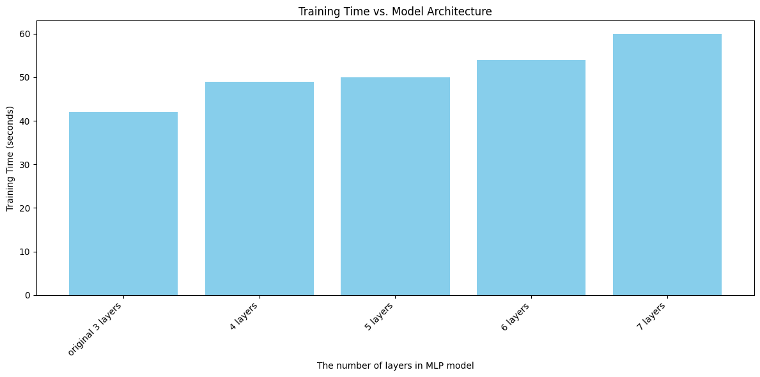

1. Performance Changes:
2. RMSE (Root Mean Square Error)
3. MAE (Mean Absolue Error)
4. MAPE (Mean Absolute Percentage Error)
5. R2 (R Squared) are used to compare the model performance.

General understanding about those metrics

| Metrics | Description | Interpretation |
| --- | --- | --- |
| RMSE | Measures prediction error magnitude. i.e., how far the model prediction are from the actual value | Lower = better (0 = perfect prediction) |
| MAE | Calculates average absolute error. | Lower = better (less sensitive to outliers) |
| MAPE | Shows percentage error. | Lower = better (eg 7% = 7% average error) |
| R2 | Explains variance in data. | Higher = better ( 1= perfect, 0 = no better than horizontal line, Negative value = worse than mean) |

The below figures represent deeper layers model performance comparison in terms of RMSE, MAE, MAPE and R2.

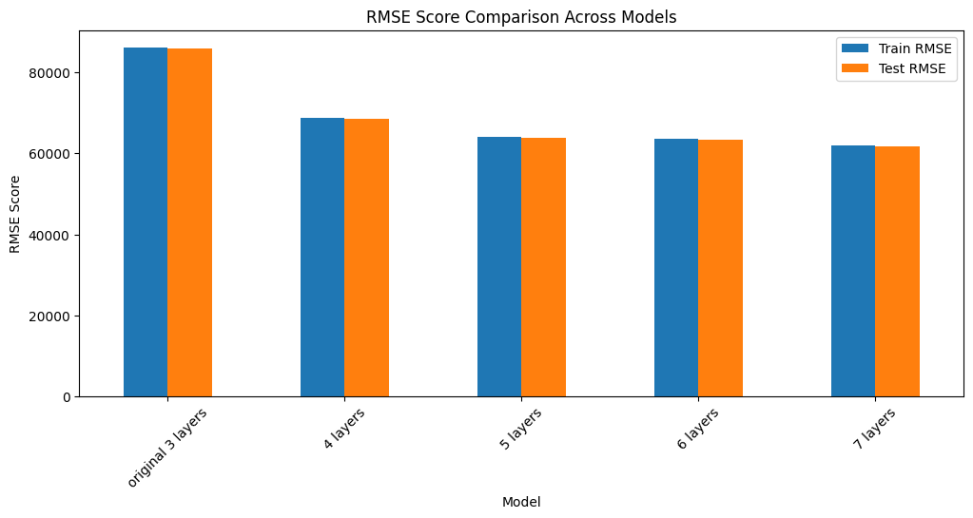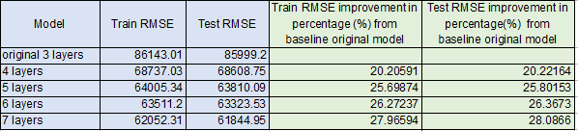

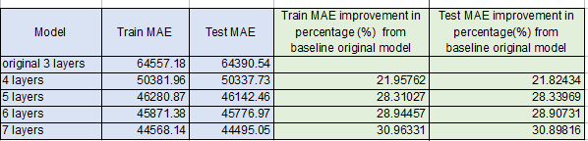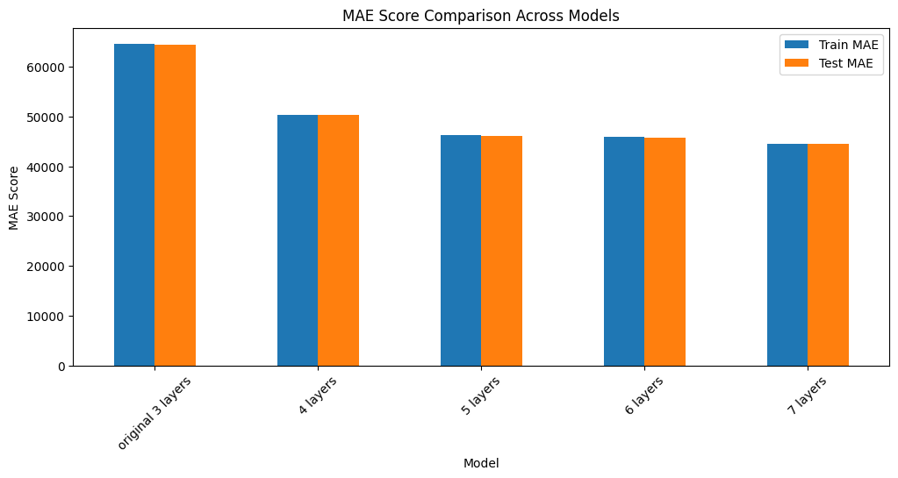

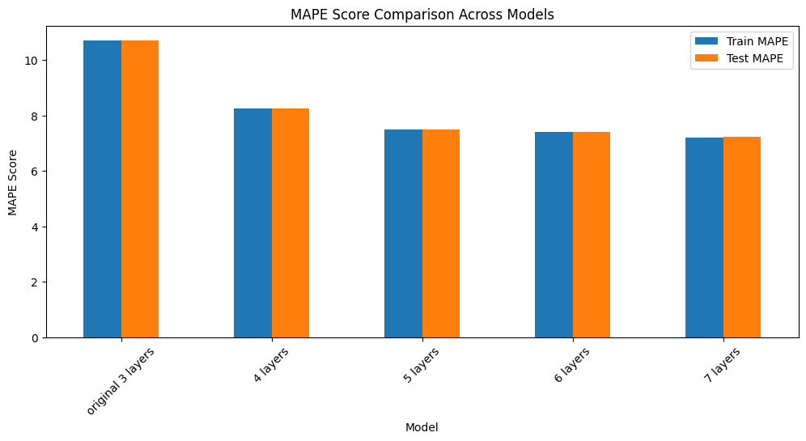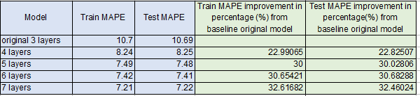

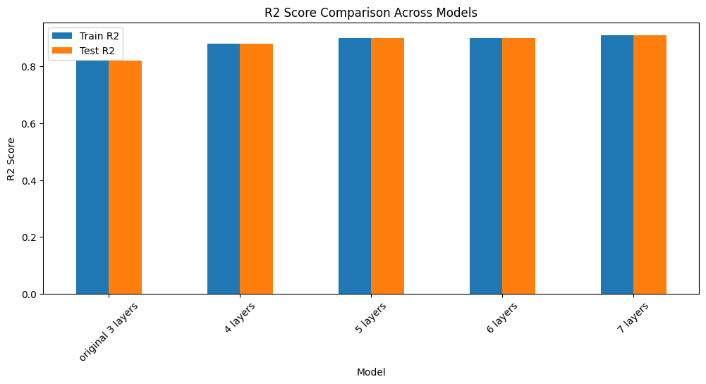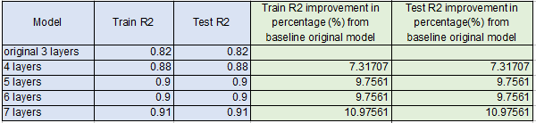

Figure Both training and test metrics comparison

Increasing neural network depth from 3 to 7 layers significantly improves model performance. The 7-layer architecture demonstrates better results, reducing test RMSE by 28% (85,999 → 61,845) and test MAE by 30.8%, while improving prediction accuracy (MAPE) by 32.4%. The R² score also increases by 10.9%, confirming better explanation of data patterns.

Deeper neural netowrk (with more layers) achieve better performance because they can learn more complex patterns in the data. For example, while 3 layer model might only identify baseic features, a higher layers combine those basic feature into higher-order patterns to understand the complex data.